Lab 6: Advanced Tableau IV

Name: Amisha Farhana Shaik

1. Showing statistics and forecasting: use the analytics pane and trend lines:
(1). Build a trend line between weight and standard cost, enable confidence interval, are the correlation coefficient between these two facts significant? Yes, they have negative and significant correlation coefficient.
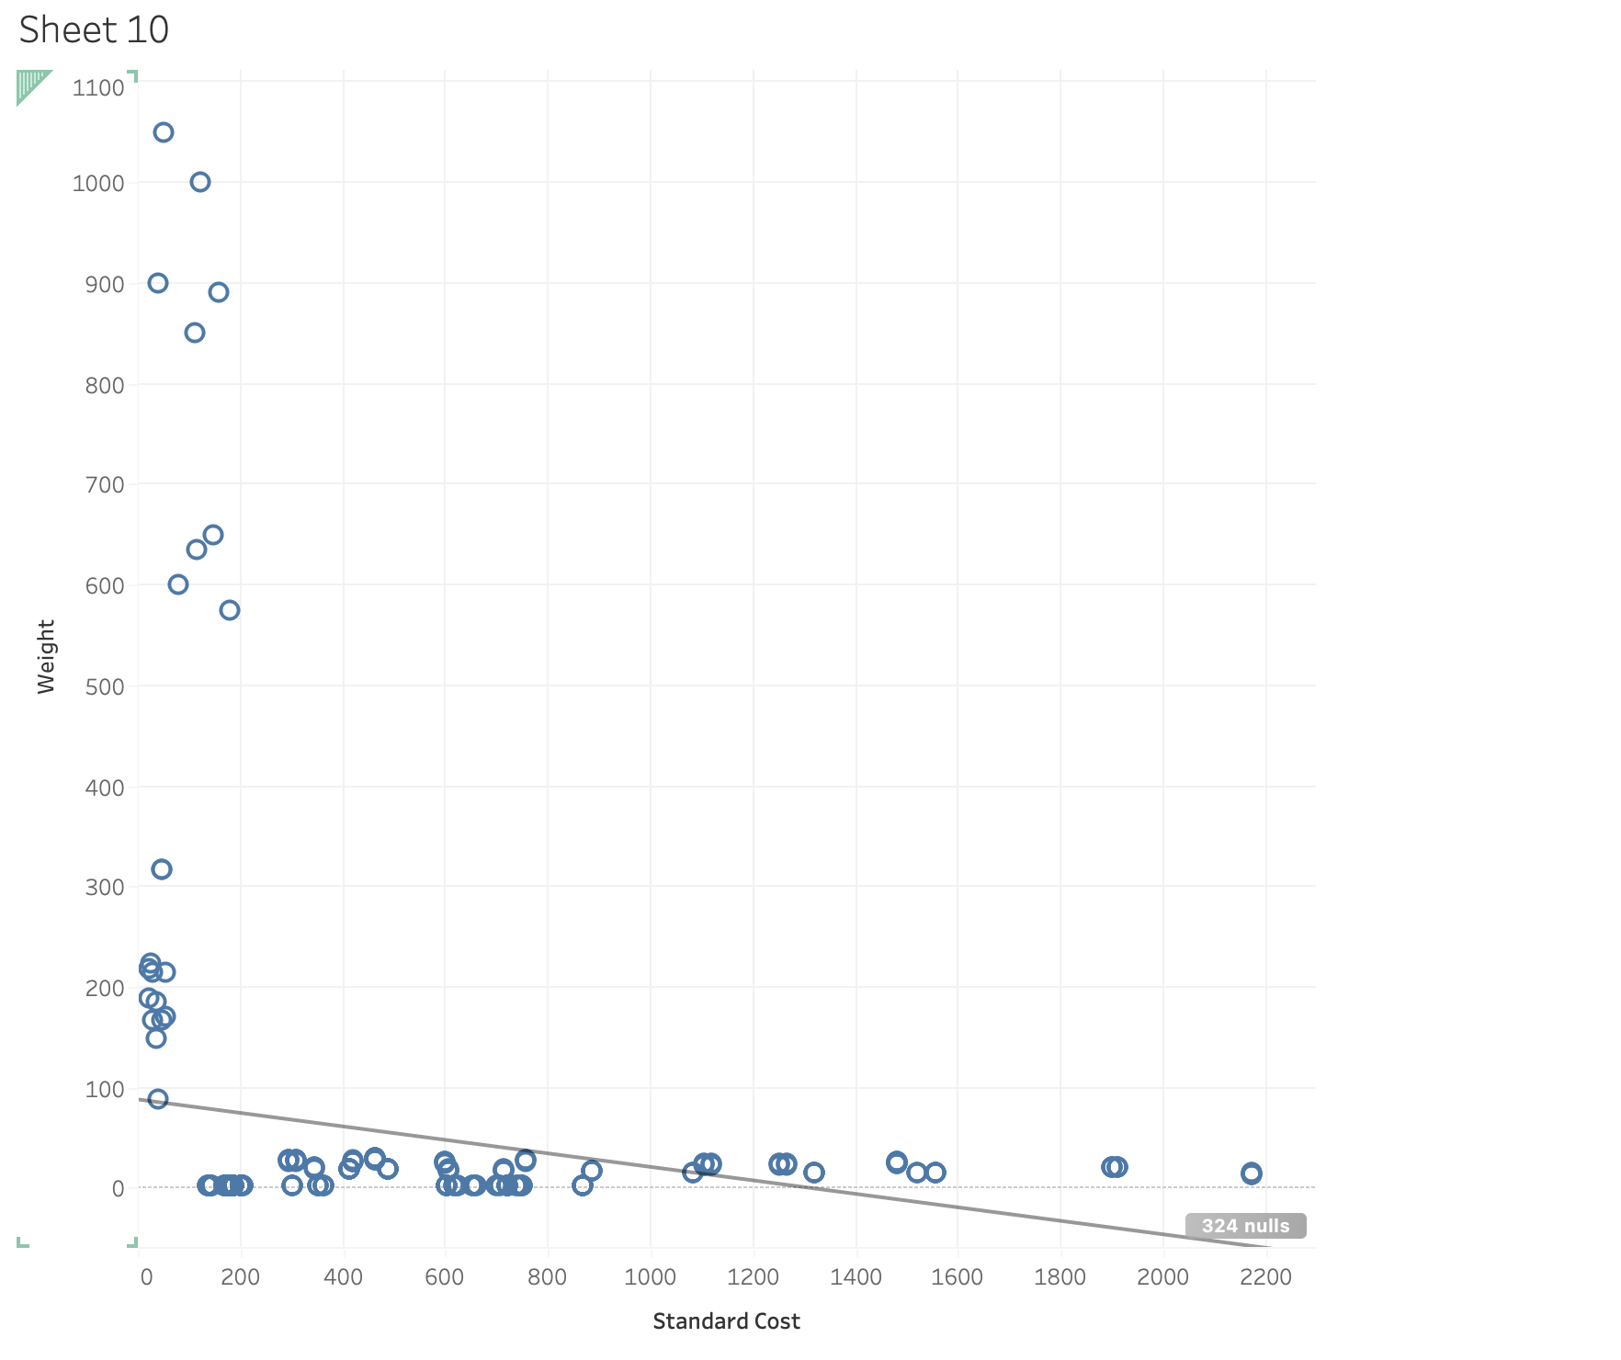
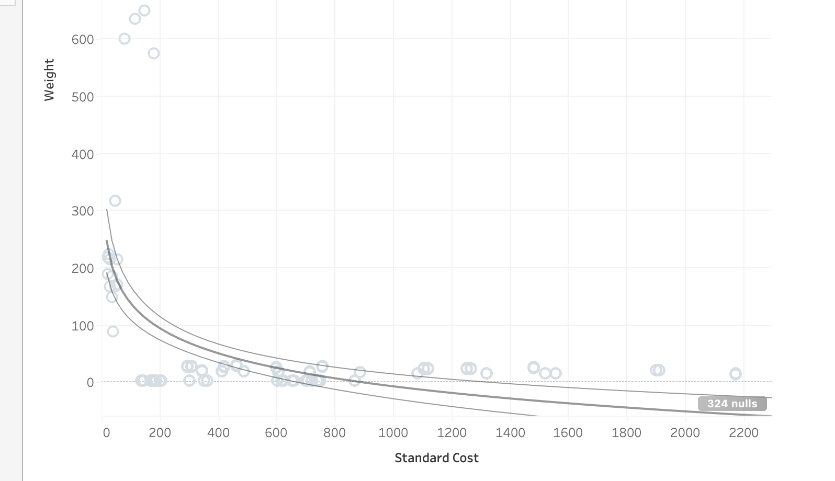
(2). Generate a forecast in the View: build a forecast line to predict the sum of sales amount in 2015 (order date);
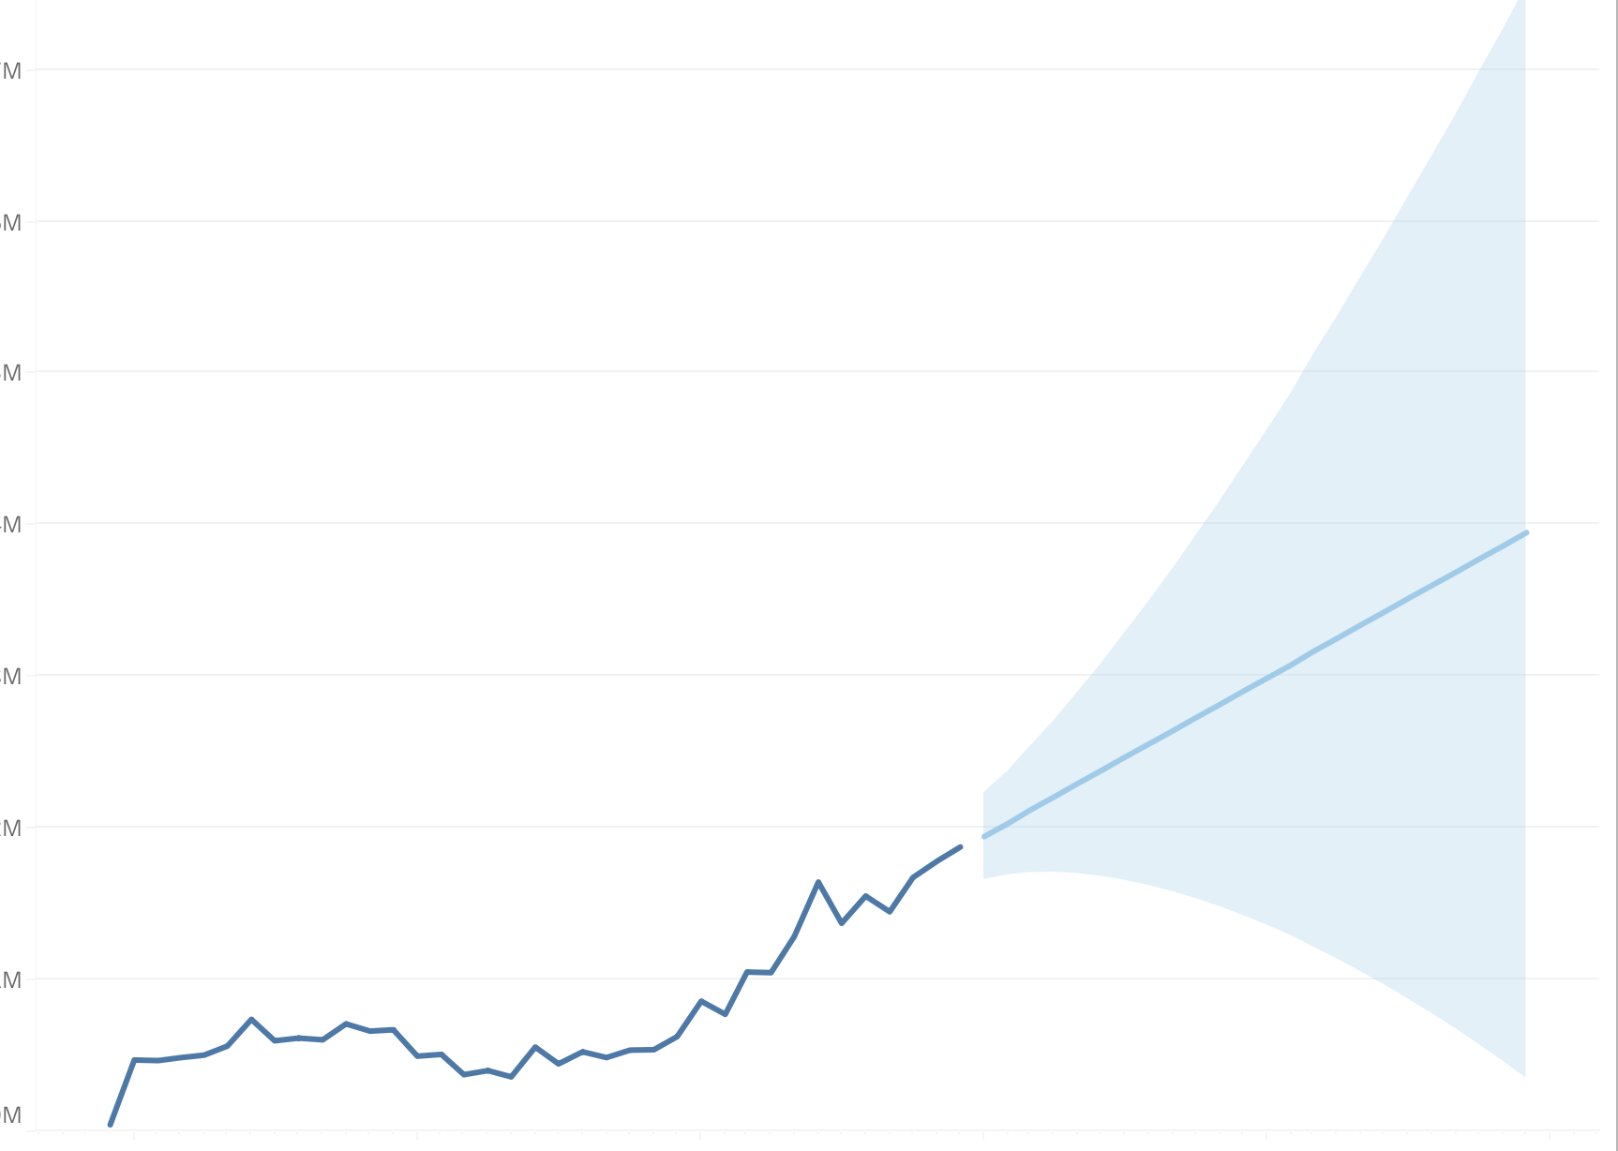

2. Find Clusters in Data:
(1). Find clusters in the scatterplot of weight and product cost from production dimension; How many clusters are generated automatically?
- 3 clusters generated by default.
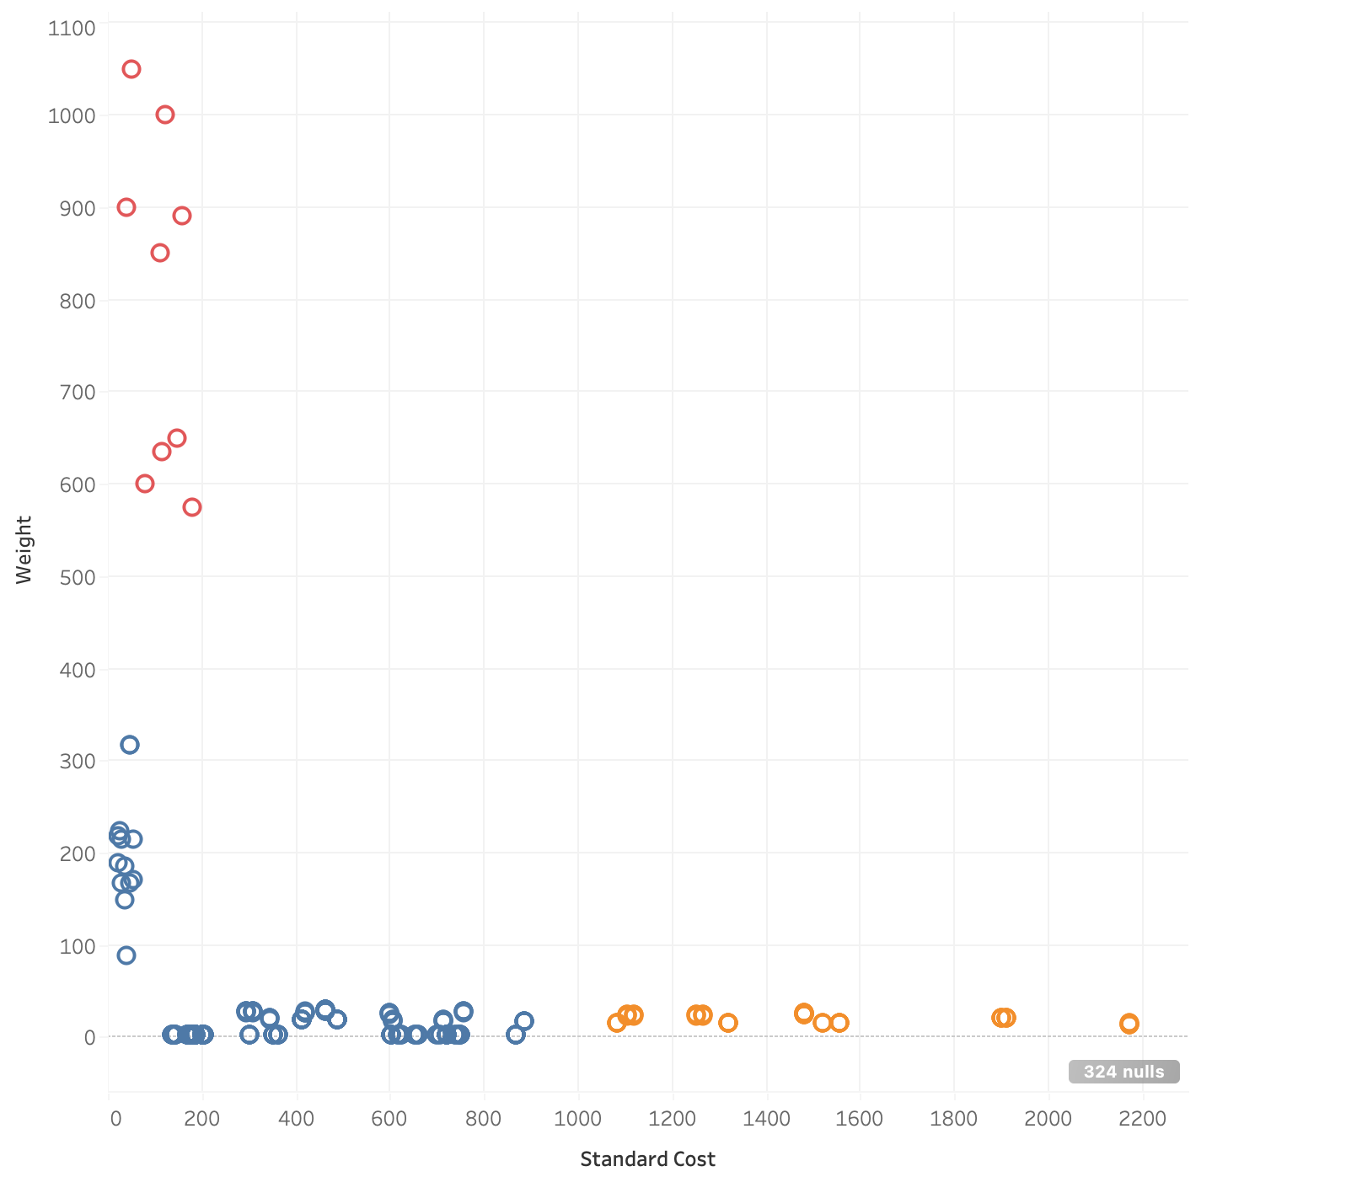
Distinguish these clusters using different colors;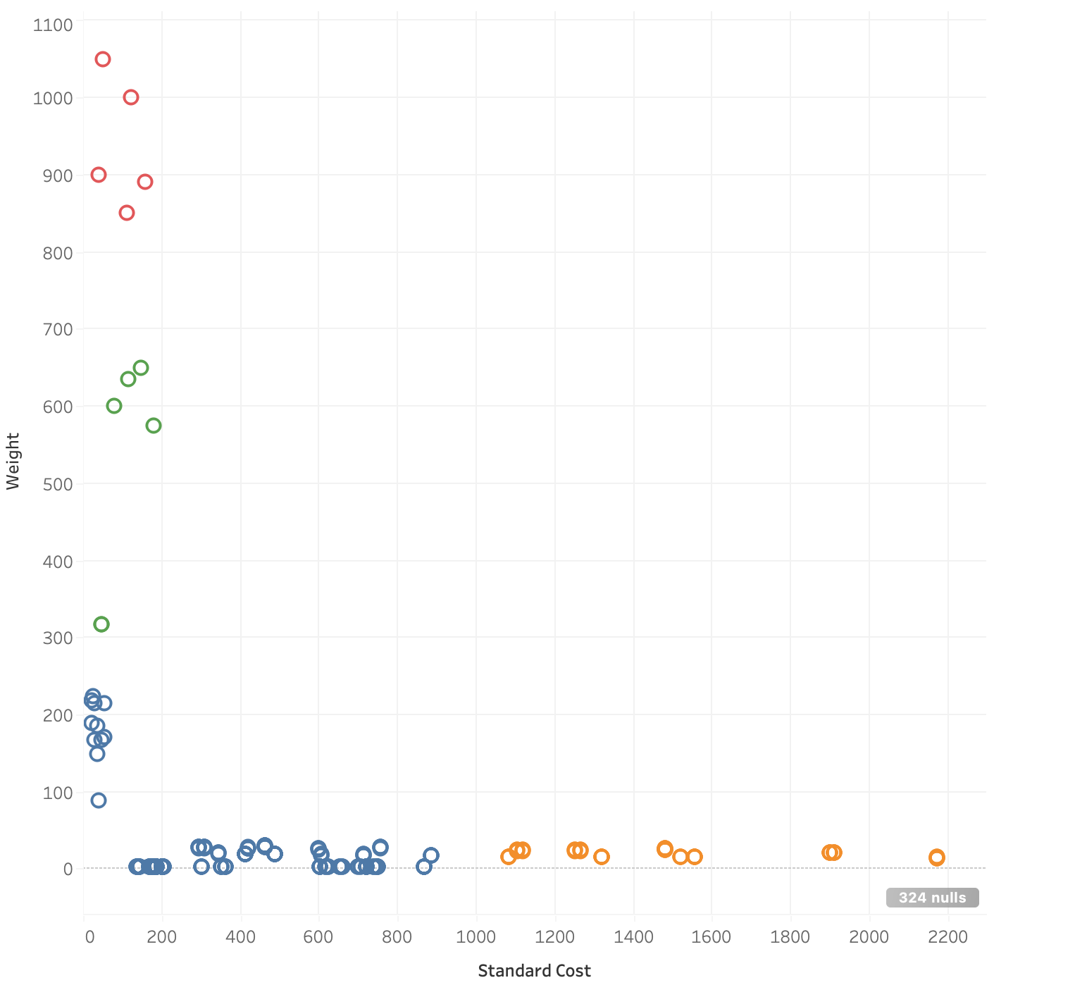

(2). Display only cluster 1 and cluster 2 in the view; Save clusters as groups in the data field, and rename the groups;

